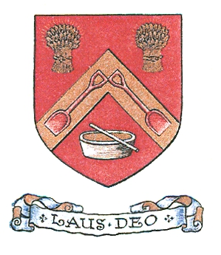

INCORPORATION of MALTMEN in GLASGOW

APPLICATION TO BE ADMITTED
A MEMBER of the INCORPORATION at the FAR HAND

1. Name of Applicant

2. Address

3. Email Address
4. Date of Birth
4. 5. Date of Burgess Ticket (if already obtained)
- 6. Signature of Applicant

7. Date of Application
8. Entry Money Payable | A – Entry Fee as Follows:-  Aged Up to 30 years £50.00  Aged Between 30-60 years £75.00  Aged Over 60 years £50.00 £……….  B – Burgess Ticket (if not already held): £30 £……….  C – Matriculation Fee: £25 (£5 if under 26) £……….  (Payable if you are not yet a member of a  Trades House Incorporation)

Please see the attached for the Incorporation's Privacy Notice

Please lodge the completed forms and payment (cheques to be made payable to Monteith Solicitors Client Account) with the Clerk:-

Thomas W. Monteith
Incorporation of Maltmen in Glasgow
9 George Square
Glasgow
G2 1QQ

Scottish Charity No. SC002427

